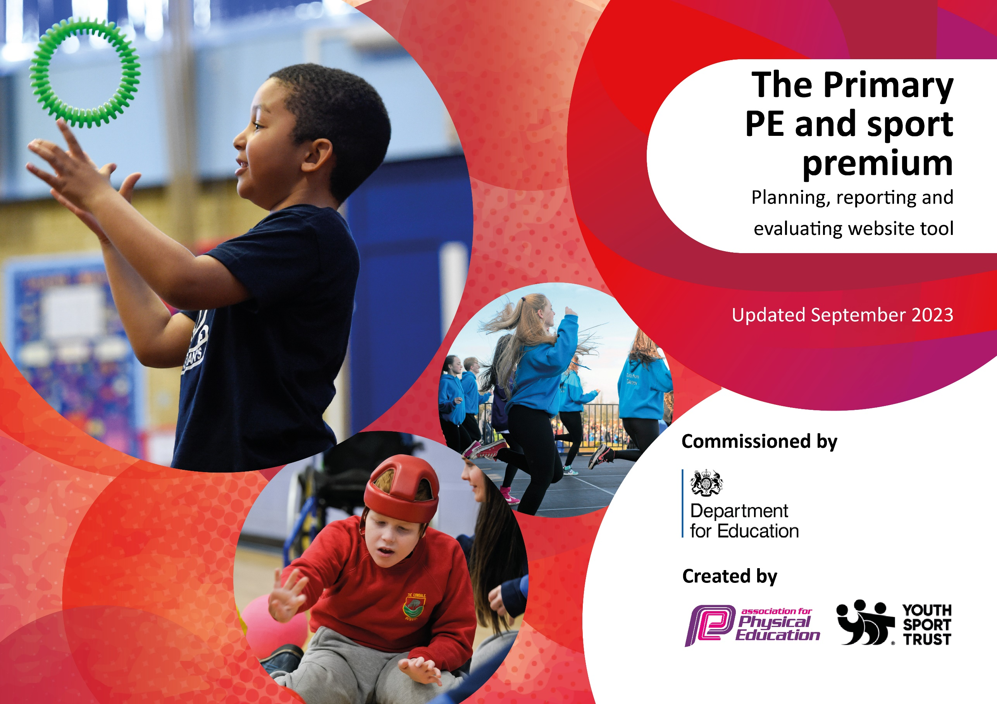

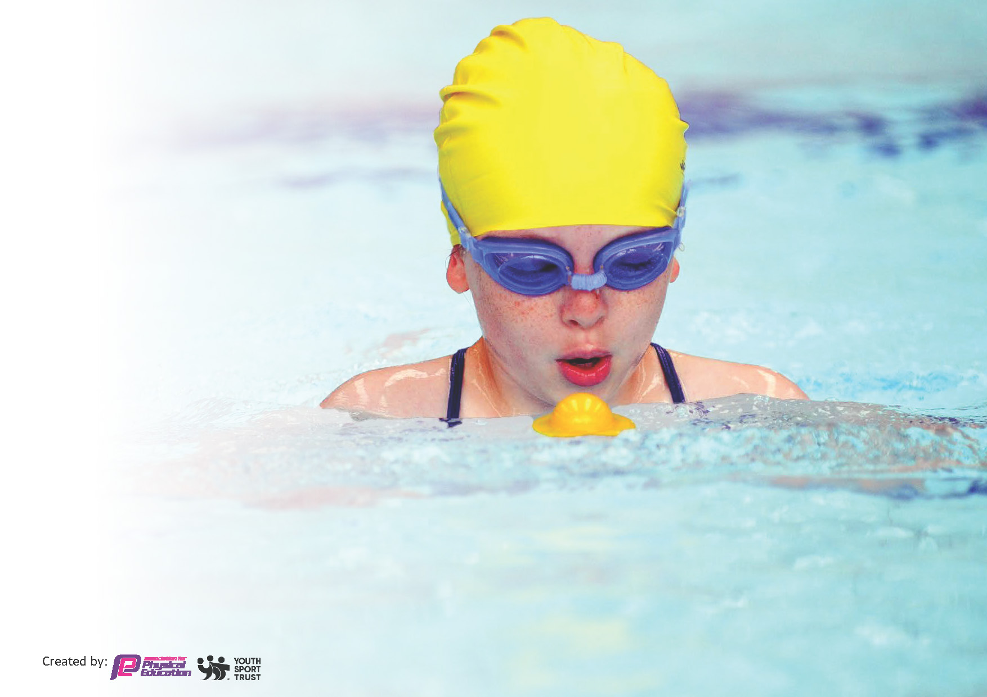
This template can be used for multiple purposes:
by:
- It enables schools to effectively plan their use of the Primary PE and sport premium
- It helps schools to meet the requirements (as set out in guidance) to publish information on their Primary PE and sport premium
- It will be an effective document to support Ofsted inspections enabling schools to evidence progress in Physical Education (PE) and evidence swimming attainment, which forms part of the PE National Curriculum. We would recommend schools consider
the Intent, Implementation and Impact of any spend, as examined within the Education Inspection Framework.

It is important that your grant is used effectively and based on school need.

Schools must use the funding to make additional and sustainable
improvements to the quality of the PE, School Sport and Physical Activity (PESSPA)
they offer. This means that you should use the Primary PE and sport premium to:

- Build capacity and capability within the school to ensure that improvements made now will benefit pupils joining the school in future years
- Develop or add to the PESSPA activities that your school already offers.

The Primary PE and sport premium should not be used to fund capital spend projects; the school’s core budget should fund these. Further detail on capital expenditure can be found in the updated Primary PE and sport premium guidance.

The Primary PE and sport premium guidance, outlines 5 key priorities that funding should be used towards. It is not

necessary that spending has to meet all the key priorities, you should select the priorities that you aim to use any funding towards.

Although completing this template is not a requirement for schools, schools are required to publish details of how they spend this funding. Schools must also outline what the impact this funding has had on pupils’ PE and sport participation and attainment and how any spending will be sustainable in the future. All funding must be spent by 31st July 2024.

The Department for Education has worked closely with the Association for Physical Education (afPE) and the Youth Sport Trust (YST) to develop this template and encourages schools to use it. This template is an effective way of meeting the reporting requirements of the Primary PE and sport premium.
Review of last year’s spend and key achievements (2022/2023)

We recommend you start by reflecting on the impact of current provision and reviewing your previous spend.

Activity/Action | Impact | Comments
Being part of Dacorum Schools Sports Network (DSSN) | Enabled children to take part in a range of different activities e.g. Tri golf, Girls football.  Enabled children to put into practice in a competitive way the skills that they are learning in the classroom. | Continue to be part of the network again in 2023-2024.
Extra-curricular sport activities | Children have a range of extra-curricular activities which include, basketball, football, netball, yoga, Taekwando. | Continue with the extra-curricular offer into 2023-2024.
DSSN Awards | A significant number of Boxmoor children were entered for the DSSN Sports Awards in July 2023. Boxmoor had a number of children win the awards for their sporting efforts as well as several runners up. | Continue to celebrate the sporting achievements of our children both in and out of school in 2023-2024.

Key priorities and Planning
This planning template will allow schools to accurately plan their spending.

Action – what are you planning to do | Who does this action impact? | Key indicator to meet | Impacts and how sustainability will be achieved? | Cost linked to the action
Introduce a new lunchtime system which includes a range of different activities for the children. | Midday supervisors who need to lead the activities.  Children taking part.  Play leaders who are supporting the activities. | Key indicator 2 -The engagement of all pupils in regular physical activity – the Chief Medical Officer guidelines recommend that all children and young people aged 5 to 18 engage in at least 60 minutes of physical activity per day, of which 30 minutes should be in school.  Key indicator 4: Broader experience of a range of sports and activities offered to all pupils. | More pupils meeting their daily physical activity goal, more pupils encouraged to take part in PE and Sport Activities. | £5000 for resourcing and staffing costs.
To be part of Dacorum Schools Sports Network. | Staff who will be attending the sporting events.  Children taking part in sporting events.  Staff who will be attending training and development sessions. | Key indicator 1: Increase confidence, knowledge and skills of all staff in teaching PE and sport  Key indicator 4: Broader experience of a range of sports and physical activities offered to all pupils  Key indicator 5: Increased participation in competitive sport | More staff will have the confidence to teach PE sessions.  More children will have experienced a range of different sports including competitive events, where applicable. | £1300 for DSSN membership.
To employ a Sports Coach for one lunchtime and afternoon a week. | Staff working alongside the coach.  Children taking part in the sporting session. | Key indicator 1: Increase confidence, knowledge and skills of all staff in teaching PE and sport  Key indicator 4: Broader experience of a range of sports and physical activities offered to all pupils  Key indicator 5: Increased participation in competitive sport | Staff will be supported to deliver high quality PE sessions.  Children will develop new skills within PE.  Children will have the opportunity to learn new sports and take part in competitive events. | £4000 to pay for the coaching sessions.
To support Year 6 Bikeability sessions. | Year 6 children taken part in cycle training. | Key indicator 4: Broader experience of a range of sports and physical activities offered to all pupils | Children will be competent and confident to ride their bikes to and from school. | £300 to support the cycle training course.
To continue to provide high quality PE lessons to all children. | Staff delivering the lessons.  Children taking part in them. | Key indicator 3: The profile of PE and sport is raised across the school as a tool for whole school improvement  Key indicator 4: Broader experience of a range of sports and physical activities offered to all pupils | Children will be proficient in PE skills as identified in the National Curriculum and school’s long term map.  Resources will be provided so that teachers can deliver their lessons according to the NC and school’s curriculum. | £2,000 to replenish equipment.

Key achievements 2023-2024
This template will be completed at the end of the academic year and will showcase the key achievements schools have made with their Primary PE and sport premium spending.

Activity/Action | Impact | Comments
Introduce a new lunchtime system which includes a range of different activities for the children. | With a wide range of activities available, this has enabled children to keep active for the recommended 30mins per day in school towards their 60 active minutes.  It has enabled children to have access to a wider range of sporting activities including archery and tennis. | Continue with a similar system for lunchtime structured activities for the 2024-2025 academic year, and continue to offer a range of different activity stations.
To be part of Dacorum Schools Sports Network. | Enabled children to take part in a range of different activities e.g. Girls football, Dodgeball, Tag rugby, cross country.  Enabled children to take part in sports they may not have an opportunity to take part in outside of school and further develop their skills.  Enabled children to put into practice in a competitive way the skills that they are learning in PE lessons.  Enabled Sports Ambassadors the skills, abilities and confidence to lead sporting activities and events throughout the year to younger pupils in the school. | To continue to be part of the Dacorum School Sports Network for the academic year 2024-25 and continue to offer a wide range of sporting activities.

Swimming Data
Meeting National Curriculum requirements for swimming and water safety.
Priority should always be given to ensuring that pupils can perform safe self-rescue even if they do not fully meet the first two requirements of the National Curriculum programme of study

Question | Stats: | Further context  Relative to local challenges
What percentage of your current Year 6 cohort can swim competently, confidently and proficiently over a distance of at least 25 metres? | 90%
What percentage of your current Year 6 cohort can use a range of strokes effectively [for example, front crawl, backstroke, and breaststroke]? | 90%

What percentage of your current Year 6 cohort are able to perform safe self-rescue in different water-based situations? | 83%
If your schools swimming data is below national expectation, you can choose to use the Primary PE and sport premium to provide additional top-up sessions for those pupils that did not meet National Curriculum  requirements after the completion of core lessons. Have you done this? | No
Have you provided CPD to improve the knowledge and confidence of staff to be able to teach swimming and water safety? | No

Signed off by:

Head Teacher: | Vicky Campos
Subject Leader or the individual responsible for the Primary PE and sport premium: | Cheryl Todiresei
Governor: | Andrew Tucker (Sports Premium Governor)
Date: | 9th July 2024

